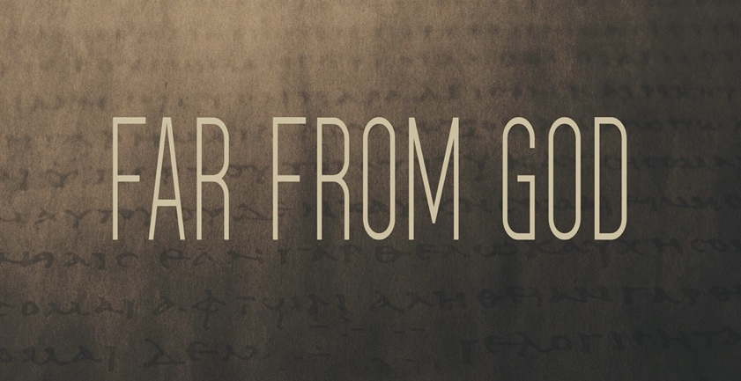
Loophole Religion
_______________holes: Ways _______________ the rules that technically don’t _______________ the rules.
Do you ever try to figure out how _______________ you can get to _______________ without actually _______________?
Do you believe there is a _______________ that makes you right with _______________ while removing your _______________ to make things right with _______________?
Do you feel guiltier about _______________ _______________ than _______________ someone at work?
Are you banking on the myth that God has _______________-_______________ memory loss?
Kingdom of _______________
_______________ of Christ
To love _______________ as God, through Christ has _______________ _______________.
What does _______________ require of _______________?
You have let go of the commands of God and are holding on to human traditions.”
Mark 7:8, NIV
Loophole Religion
_______________holes: Ways _______________ the rules that technically don’t _______________ the rules.
Do you ever try to figure out how _______________ you can get to _______________ without actually _______________?
Do you believe there is a _______________ that makes you right with _______________ while removing your _______________ to make things right with _______________?
Do you feel guiltier about _______________ _______________ than _______________ someone at work?
Are you banking on the myth that God has _______________-_______________ memory loss?
Kingdom of _______________
_______________ of Christ
To love _______________ as God, through Christ has _______________ _______________.
What does _______________ require of _______________?
You have let go of the commands of God and are holding on to human traditions.”
Mark 7:8, NIV

