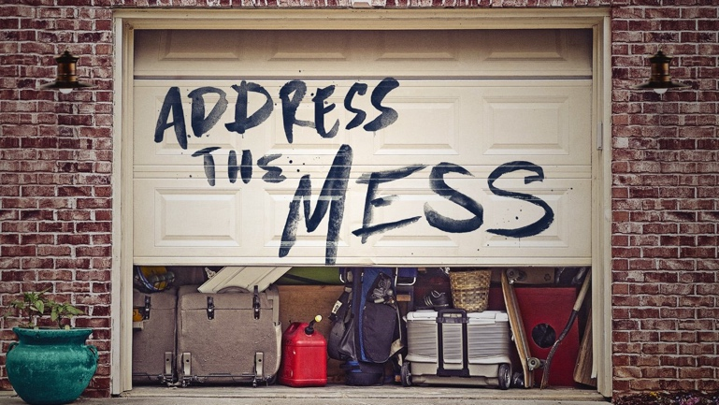
Inside Out
I know a mess when I _______________ one because I _______________ one.
Jesus _______________ the little messes, all the messes of the _______________.
He loves us too much to _______________ us that way.
Christianity is an _______________ _______________ faith.
Help me to _______________ as you see and _______________ as you say.
Following Jesus is not primarily about doing what’s _______________.
It’s doing what’s _______________ for _______________.
“Heavenly Father, _______________ the work you’ve _______________ in me.”

… always in every prayer of mine for you all making my prayer with joy, because of your partnership in the gospel from the first day until now. And I am sure of this, that he who began a good work in you will bring it to completion at the day of Jesus Christ.
Philippians 1:4-6, ESV

Inside Out
I know a mess when I _______________ one because I _______________ one.
Jesus _______________ the little messes, all the messes of the _______________.
He loves us too much to _______________ us that way.
Christianity is an _______________ _______________ faith.
Help me to _______________ as you see and _______________ as you say.
Following Jesus is not primarily about doing what’s _______________.
It’s doing what’s _______________ for _______________.
“Heavenly Father, _______________ the work you’ve _______________ in me.”

… always in every prayer of mine for you all making my prayer with joy, because of your partnership in the gospel from the first day until now. And I am sure of this, that he who began a good work in you will bring it to completion at the day of Jesus Christ.
Philippians 1:4-6, ESV

