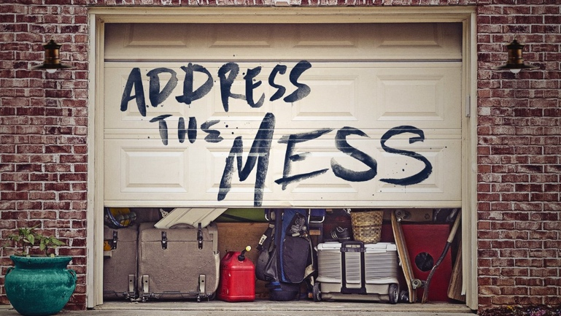
Messy-Er

Messy-_______________.
Do unto _______________ as he intends to do unto _______________.
Ignore _______________ you will eventually make a _______________.
I’m opting for _______________ over _______________-_______________.
Every mess comes _______________ with some bad options.
Your _______________ to the mess is the _______________ _______________.
What _______________ do I want to tell?
Which of my _______________ do I want as a _______________ part of my story?

May the Lord judge between me and you, may the Lord avenge me against you, but my hand shall not be against you.
1 Samuel 24:12, ESV
Messy-Er

Messy-_______________.
Do unto _______________ as he intends to do unto _______________.
Ignore _______________ you will eventually make a _______________.
I’m opting for _______________ over _______________-_______________.
Every mess comes _______________ with some bad options.
Your _______________ to the mess is the _______________ _______________.
What _______________ do I want to tell?
Which of my _______________ do I want as a _______________ part of my story?

May the Lord judge between me and you, may the Lord avenge me against you, but my hand shall not be against you.
1 Samuel 24:12, ESV

